Developer Diary by Shane Moran – G00338607

# Unity 2018.3.7f1

# Introduction

This Developer Diary is a requirement for a 4th Year software development module, Mobile Applications Development 3. Within this, I will keep account of the thought process and development of the game.

# Entry 1

After reading the design document that was provided by the customer, I could see that he was looking for me to develop an endless running game. His main concept idea is you move an avatar through an ever-changing world and along the way you will have to jump and duck in order to stay alive.

Here are the initial key points I discussed with my customer:

* Endless Runner
  + Side scroller (left or right) or Jump or duck (up or down)
  + OR Both
* Objects
  + Coins
  + Positive Objects
  + Negative Objects
* Character
  + 1 Live
* Front End
  + Play menu
  + Pause menu
  + Options Menu
  + Exit Menu

We then agreed on the following issues to flag:

* Layout
* Split-Screen

# Entry 2

After researching into how I would go about developing the game, I began to plug away at some Unity tutorials. Unity itself provides great documentation which I used help get my character moving. When using Unity, you can use the unity engine to create all the core mechanics or by using both Unity and C#. Now I am just focusing on getting the game working with the pc keyboard.

# Entry 3

I received sounds and sprites from customer, along with a menu map for some inspiration.

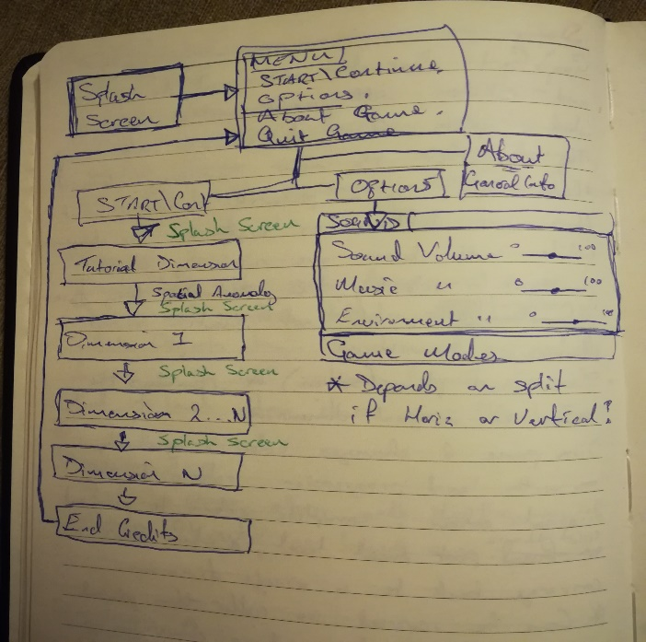

# Entry 4

My first objective was to create a tutorial level,

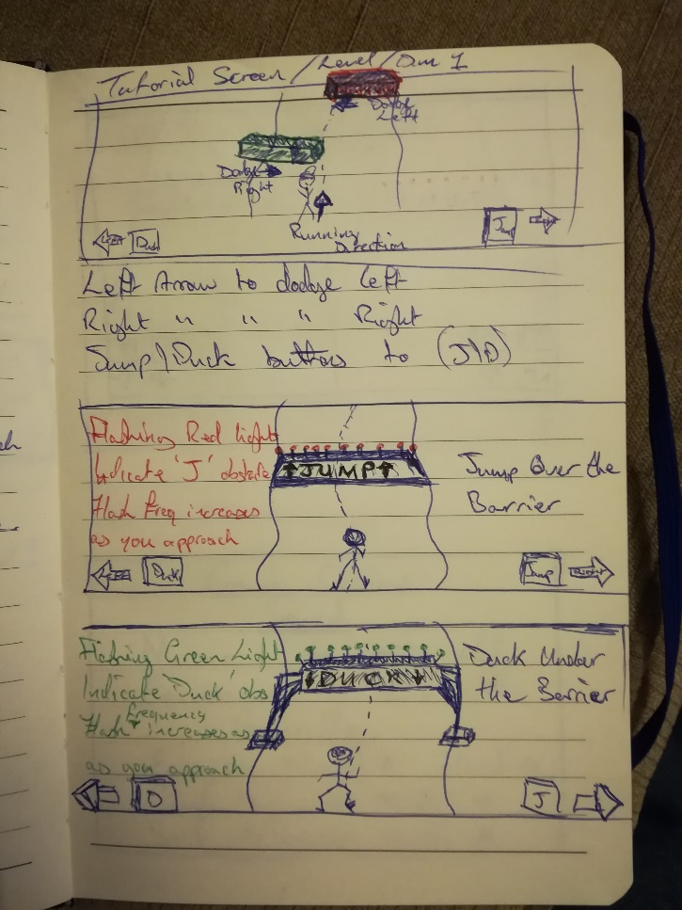

This would involve adding colliders and player movement.

# Entry 5

I then looked into creating the various menu’s such as the Main, Options and Play menus.

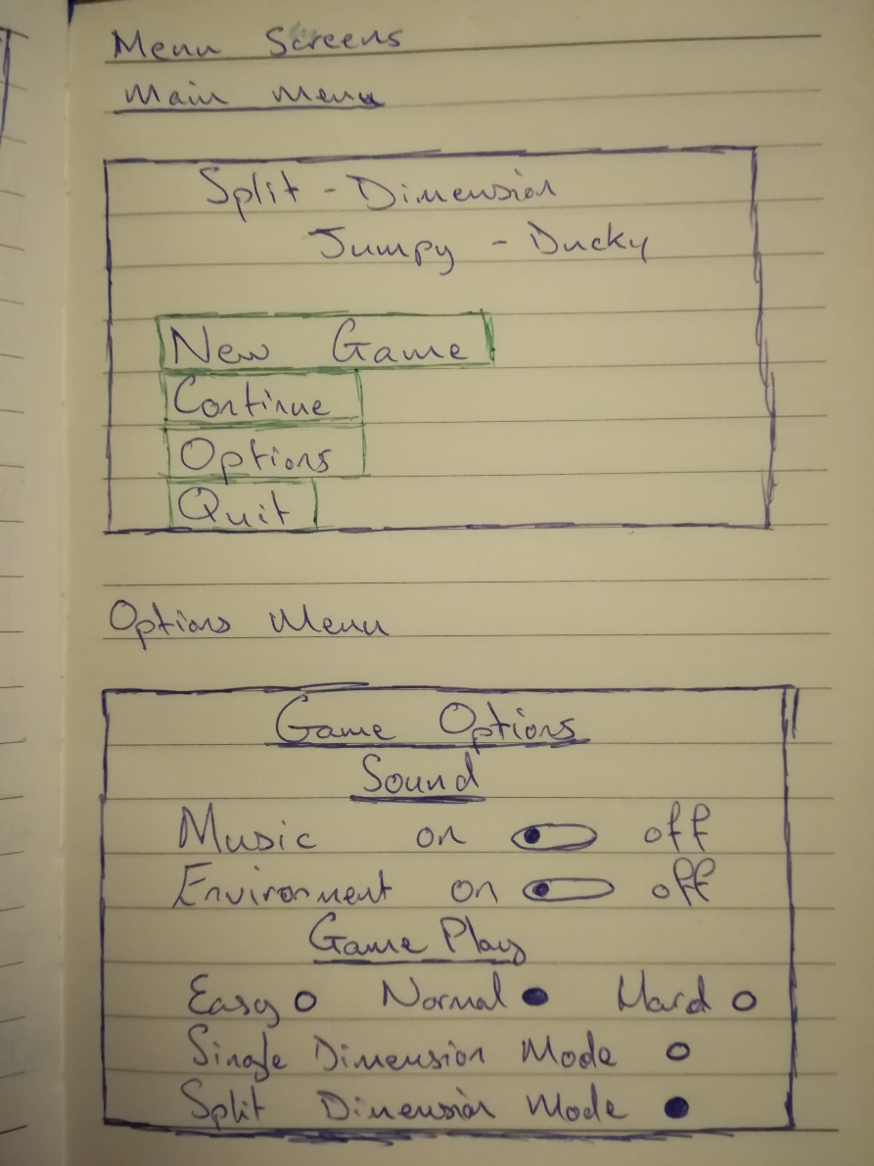

# Entry 6

I started working briefly on a main menu which included scores

# Entry 7

I search for various split screen tutorials

# REFERENCES

1. Endless Runner
   1. <https://www.youtube.com/watch?v=5M7vX_z6B9I>
2. Brackeys Menu
   1. <https://www.youtube.com/watch?v=JivuXdrIHK0&t=247s>
3. Split Screen
   1. <https://www.youtube.com/watch?v=qFNrlSi92V4&t=92s>
4. Unity 2D Guide
   1. <https://docs.unity3d.com/Manual/Unity2D.html>
5. Simple 2D Scene Setup – Code Monkey
   1. <https://www.youtube.com/watch?v=Py8akSRnwuI>

# Test Requirements

1. User must be able to start up game.
2. On start-up of the game a splash screen must be shown displaying the game and Unity logo.
3. On playing the game for the first time a tutorial should be played after the splash screen.
4. On playing the game for the second time a tutorial should not appear.
5. The user must to be able to access a new game by selecting the “Play” button.
6. The user must be able to load a previously played game by pressing the “Continue” button.
7. The user must be able to access the settings by pressing the “Options” button.
8. While within the Settings menu the user must be able to turn audio off by selecting the toggle button OR turn it up/down using a slider.

**Test Plan in folder